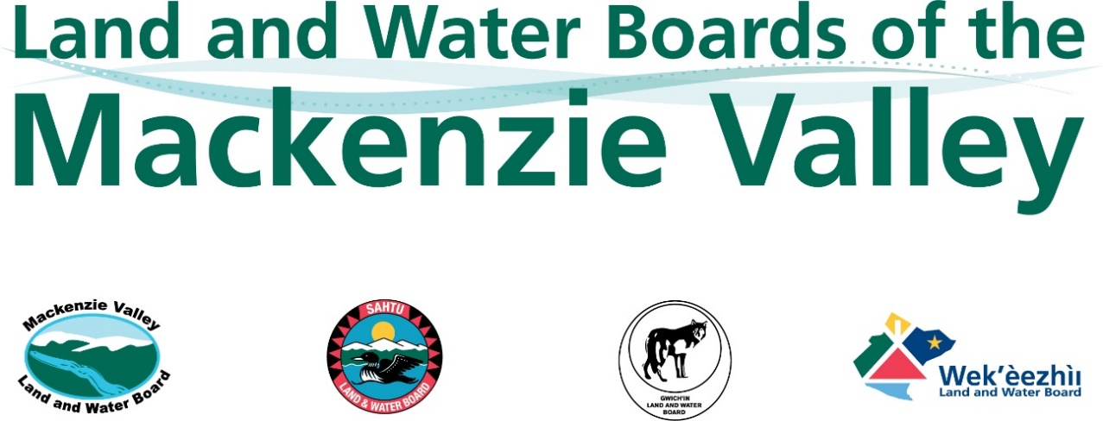

APPLICATION FOR ASSIGNMENT OF PERMIT
Section 38 of the Mackenzie Valley Land Use Regulations

Use an “X” to indicate which Board the Assignment Application is being made to: | Mackenzie Valley Land and  Water Board: |  | Sahtu Land and Water Board:
 | Wek’èezhìi Land and Water Board: |  | Gwich’in Land and Water Board:

To complete this Form, please refer to the MVLWB Guide to the Land Use Permitting Process (Guide) and fill in the grey fields; attach additional pages, as necessary. Review the following guidance for formatting your Application Package:

- Document Submission Standards
- Standard Outline for Management Plans

Reference the existing or current
Land Use Permit number(s) to be assigned:
If this Assignment Application is accompanied by an Assignment Application for a Water Licence, provide the Licence number to be assigned: |  | Water Licence – in a non-federal area:
 |  | Water Licence – in a federal area:
If applicable, list any other authorizations that will not be assigned, and provide rationale:

NAME AND CONTACT INFORMATION – CURRENT PERMITTEE (ASSIGNOR)
Name of Representative
for the Permittee:
Position:
Company Name:
Mailing Address:
Community: |  | Telephone:
Prov/Terr: |  | Email:
Postal Code: |  | Other:

NAME AND CONTACT INFORMATION – PROPOSED ASSIGNEE
Include a Certificate of Corporate Registration from the Government of the Northwest Territories in your Application Package.
Name of Representative
for the proposed Assignee:
Position:
Company Name:
Mailing Address:
Community: |  | Telephone:
Prov/Terr: |  | Email:
Postal Code: |  | Other:

RIGHTS AND/OR CONTRACTS TO SUPPORT ELIGIBILITY
Refer to section 18 of the Mackenzie Valley Land Use Regulations. Contact Indigenous, federal, and territorial governments, and other parties to ensure all appropriate rights, authorizations, permissions, dispositions, and contracts have been obtained/transferred or are in the process of being obtained/transferred (e.g., mineral exploration rights, quarry permits, licences of occupation, leases, access agreements and authorizations, etc.). List and provide confirmation of other authorizations that relate to your activities (e.g. rights, permits, licences, etc.).

ADDITIONAL SUPPORTING INFORMATION
Use the grey field below to provide or reference the following information:

Engagement: Conduct engagement specific to the proposed assignment, prepare an Engagement Record in accordance with the MVLWB Engagement Guidelines for Applicants and Holders of Water Licences and Land Use Permits, and include it in your Application Package. Templates are provided in the Guidelines. Please also refer to Information for Proponents on MVLWB’s Engagement Requirements.

Closure Cost Estimate: Prepare a Closure Cost Estimate and include it in your Assignment Application Package. Proposed Assignees are encouraged to contact the Board, prior to applying, to determine which closure-cost-estimate is most suited to the project activities. Additional guidance is provided in section 2.2 of the MVLWB/INAC/GNWT Guidelines for Closure and Reclamation Cost Estimates for Mines. If this Assignment Application is submitted concurrently with a Water Licence Assignment Application(s), the estimate should include a breakdown of water- and land-related activities and liabilities.

PROPOSED ASSIGNMENT DATE
Indicate the proposed assignment date in the grey field provided below.

FEE
Refer to section 38 and Schedule 1, item 3 of the Mackenzie Valley Land Use Regulations.
Type of Fee | Amount ($)
Assignment Application fee:

- SIGNATURE – CURRENT PERMITTEE (ASSIGNOR)
In authorizing the signing of this Form, the Permitee (Assignor) acknowledges and accepts continued responsibility for all obligations and liabilities under the Permit, the Mackenzie Valley Land Use Regulations and the Mackenzie Valley Resource Management Act, should the Board not authorize the assignment.
Name of Representative for the  Permittee (Assignor) (print) | Position (print)

Signature | Date

- SIGNATURE – PROPOSED ASSIGNEE
In authorizing the signing of this Form, subject to the Board authorizing the assignment of the Permit, the proposed Assignee acknowledges and accepts the following responsibilities:

- Meeting all the conditions of the Permit, including payment of security, which must be posted before the proposed Assignee can commence activities;
- Meeting any and all requirements found in the Mackenzie Valley Land Use Regulations and the Mackenzie Valley Resource Management Act; and
- All liabilities incurred as a result of the Assignor’s actions to date under the Permit.

Name of Representative for the  proposed Assignee (print) | Position (print)

Signature | Date

Please submit completed applications to the Regulatory Manager or Executive Director identified on the “Contact Us” pages of the respective Land and Water Board (www.mvlwb.com, www.wlwb.ca, www.slwb.com, www.glwb.com).

