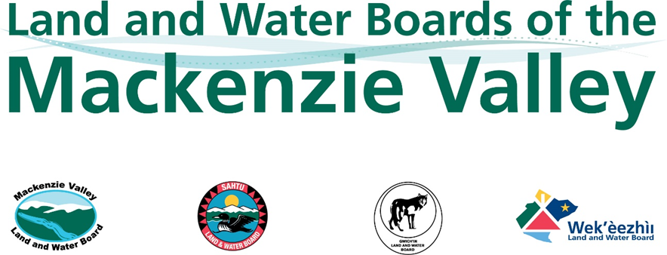

APPLICATION FOR ASSIGNMENT OF LICENCE IN FEDERAL AREAS

Section 72.14 of the Mackenzie Valley Resource Management Act and Section 10 of the Mackenzie Valley Federal Areas Waters Regulations

Use an “X” to indicate which Board the Assignment Application is being made to: | Mackenzie Valley Land and  Water Board: |  | Sahtu Land and Water Board:
 | Wek’èezhìi Land and Water Board: |  | Gwich’in Land and Water Board:

To complete this Form, please refer to the MVLWB Guide to the Water Licensing Process (Guide) and fill in the grey fields; attach additional pages, as necessary. Review the following guidance for formatting your Application Package:

- Document Submission Standards
- Standard Outline for Management Plans

Provide the existing or current
Water Licence number(s) to be assigned:
If this Assignment Application is accompanied by an Assignment Application for a Licence in a non-federal area and/or a Land Use Permit, provide the Licence and/or Permit number(s) to be assigned: | Water Licence:
 | Land Use Permit:
If applicable, list any other authorizations that will not be assigned, and provide rationale:

NAME AND CONTACT INFORMATION – CURRENT LICENSEE (ASSIGNOR)
Name of Representative
for the Licensee:
Position:
Company Name:
Mailing Address:
Community: |  | Telephone:
Prov/Terr: |  | Email:
Postal Code: |  | Other:

NAME AND CONTACT INFORMATION – PROPOSED ASSIGNEE
Include a Certificate of Corporate Registration from the Government of the Northwest Territories in your Application Package.
Name of Representative
for the Proposed Assignee:
Position:
Company Name:
Mailing Address:
Community: |  | Telephone:
Prov/Terr: |  | Email:
Postal Code: |  | Other:

ADDITIONAL SUPPORTING INFORMATION
Use the grey fields below to provide or reference the following information:
Traditional Place Name:

Rationale: Describe the reason for the proposed assignment.

Engagement: Conduct engagement specific to the proposed assignment, prepare an Engagement Record in accordance with your approved Engagement Plan and the MVLWB Engagement Guidelines for Applicants and Holders of Water Licences and Land Use Permits, and include it in your Application Package. Templates are provided in the Guidelines. Please also refer to Information for Proponents on MVLWB’s Engagement Requirements.

Eligibility: Contact Indigenous, federal, and territorial governments, and other parties to ensure all appropriate authorizations have been obtained/transferred or are in the process of being obtained/transferred. Proposed Assignees must obtain permission from the landowner, if necessary (e.g., obtain/transfer and reference licences of occupation, leases, access authorizations, etc.) and attach it/them to the Application.

Closure Cost Estimate: Prepare a Closure Cost Estimate and include it in your Assignment Application Package. Proposed Assignees are encouraged to contact Board staff, prior to applying, to determine which closure-cost-estimate template is most suited to the project activities. Guidance is provided in section 2.2 of the MVLWB/INAC/GNWT Guidelines for Closure and Reclamation Cost Estimates for Mines. If this Assignment Application is submitted concurrently with a Land Use Permit Assignment Application, the estimate should include a breakdown of water- and land-related activities and liabilities.

Financial Capacity: Provide information relating to the Assignee’s financial capacity, as outlined in 72.03(5)(d) of the Mackenzie Valley Resource Management Act. Please note this information will be required by the Board prior to its decision.

PROPOSED ASSIGNMENT DATE
Indicate the proposed assignment date in the grey field provided below.

FEE
Refer to the Guide for assistance with determining applicable fees.
Type of Fee | Amount ($)
Assignment application fee (if applicable):

- SIGNATURE – CURRENT LICENSEE (ASSIGNOR)
In authorizing the signing of this Form, the Licensee (Assignor) acknowledges and accepts continued responsibility for all obligations and liabilities under the Licence, the Mackenzie Valley Federal Areas Waters Regulations, and the Mackenzie Valley Resource Management Act, should the Board not authorize the assignment.
Name of Representative for the  Licensee (Assignor) (print) | Position (print)

Signature | Date

- SIGNATURE – PROPOSED ASSIGNEE
In authorizing the signing of this Form, subject to the Board authorizing the assignment of the Licence, the proposed Assignee acknowledges and accepts the following responsibilities:

- Meeting all the conditions of the Licence, including payment of water use fees and security, which must be posted before the proposed Assignee can commence activities;
- Meeting any and all requirements found in the Mackenzie Valley Federal Areas Waters Regulations, and the Mackenzie Valley Resource Management Act; and
- All liabilities incurred as a result of the Assignor’s actions to date under the Licence.

Name of Representative for the  Proposed Assignee (print) | Position (print)

Signature | Date

Please submit completed applications to the Regulatory Manager or Executive Director identified on the “Contact Us” pages of the respective Land and Water Board (www.mvlwb.com, www.wlwb.ca, www.slwb.com, www.glwb.com).

